Chapter 13: Piecewise-Defined Functions
Lesson 13.1 Understanding Piecewise-Defined Functions
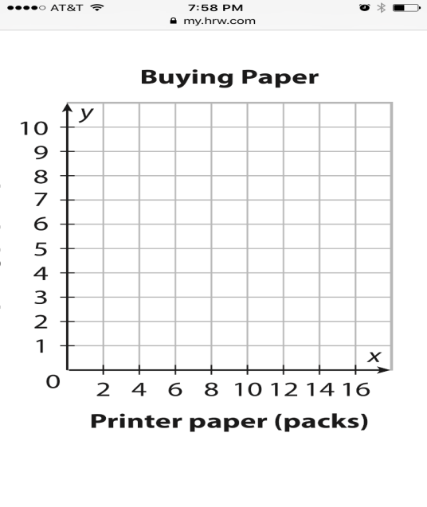
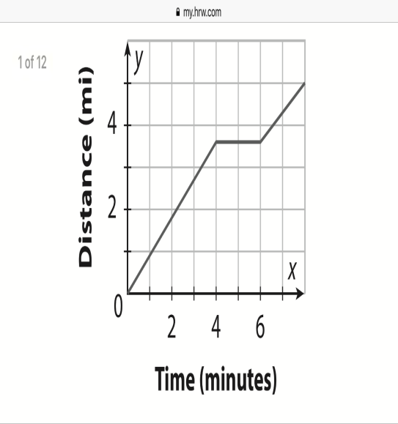
A piecewise function has different rules for different parts of its domain.

$$\left\{\begin{aligned}0.9x, if 0≤x≤4 \\ 3.6, if 4<x<6 \\ 0.7x-0.6, if 6<x≤9\end{aligned}\right.$$

Example 1:
F(x) = $\left\{\begin{aligned}-x, if x <0 \\ x+1, if x≥0\end{aligned}\right.$
Step 1: Make tables and pick values which Step 2: Graph your values.
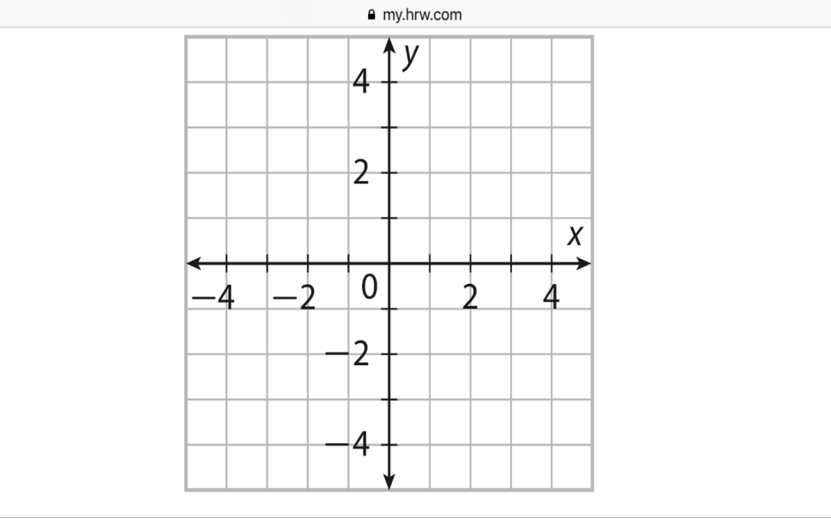
fulfill the mathematical statements.
y = (-x)
y = x + 1
Example 2:
$f\left(x\right)=\left\lfloor x\right\rfloor$
This style of bracket means the “Greatest Common Integer”
Step 1: Make tables and pick values which Step 2: Graph your values.
fulfill the mathematical statement.
$f\left(x\right)=\left\lfloor x\right\rfloor$

-3
-2.5
-1.4
0
.5
1.5
2

Example 3:
f(x) = $\left\{\begin{aligned}x, if x<2 \\ 2x+3, if x≤x<4 \\ x^{2}, if x≥4\end{aligned}\right.$
Step 1: Make tables and pick values which Step 2: Graph your values.
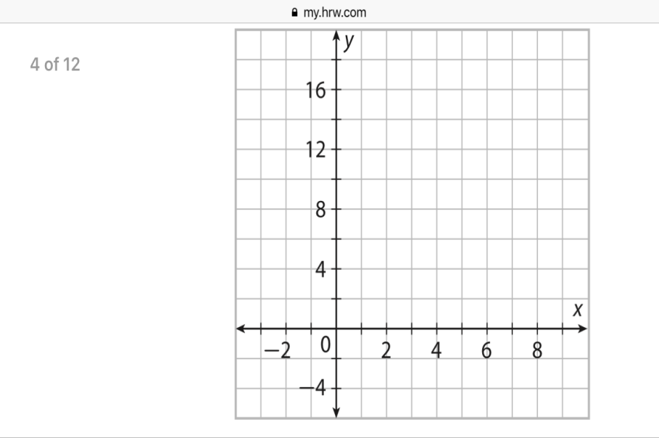
Fulfill the mathematical statement.

