**Chapter 13: Piecewise-Defined Functions.**

**Lesson 13.4: Solving Absolute Value Inequalities**

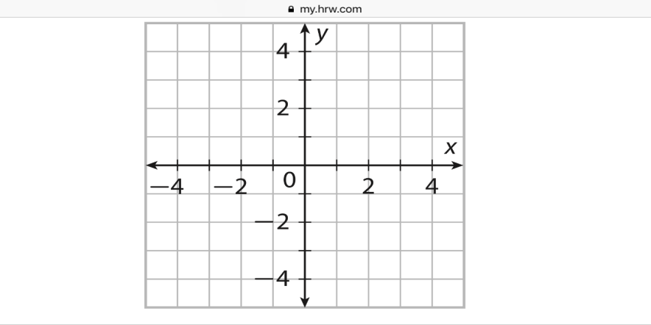**Example 1:**

$$\left|x+3\right|+1>4$$

|  |  |
| --- | --- |
| *x* |  |
| -3 |  |
| -1 |  |
| 0 |  |
| 1 |  |
| 3 |  |

**Example 2:**

$$\left|x-2\right|-3<1$$

|  |  |
| --- | --- |
| *x* |  |
| -3 |  |
| -1 |  |
| 0 |  |
| 1 |  |
| 3 |  |

cid:2F05762E-5E0D-4448-9500-ED69F7A327F4

**Example 3:** **Example 4:**

$\left|4-x\right|+15>21$ $\left|x+4\right|-10>-2$