**Section 5.3-** **Interpreting Rate of Change and Slope**

For a function defined in terms of x and y, the **rate of change** over a part of the domain of the function is a ratio that compares the change in y to the change in x in that part of the domain.

$Rate of change=\frac{Change in y}{Change in x}$ `or $m (slope)=\frac{y 2 - y 1}{x 2 - x 1}$

**Example 1:**

Find the slope between the points (3, 15) and (4, 25).

**Example 2:**

Find the slope between the points (7, 35) and (10, 50)

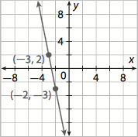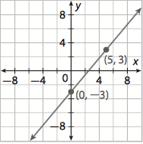**Example 3:** **Example 4:**

**Lesson 6.1- Slope Intercept Form**

**Slope Intercept Form**: y=m(x) +b where m is the slope and b is the y-intercept.

**Example 1:** **Example 2:**

Slope is 3 and (2,5) is on the line. The line passes through (0, 5) and (2,13)

**Example 3:** **Example 4:**

Slope is -1 and (3, 2) is on the line. The line passes through (1,4) and (3, 18)

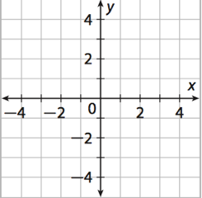**Graphing from Slope Intercept Form**

Example 1:

y = 5(x) – 4

Slope:

Y-intercept:

**Homework: Workbook Page 227-228 (1-12) & Workbook Pages 245-246 (5-20)**